**EXPERIMENT NO. 3:** Design an automatic night lighting system

(with 4 connected led’s) such the system is only activated when the

master control switch is pressed.

a) Below 50% value of full brightness all LED’s constantly ON.

b) Above 50% value of full brightness only first LED is ON.

**CIRCUIT DIAGRAM**

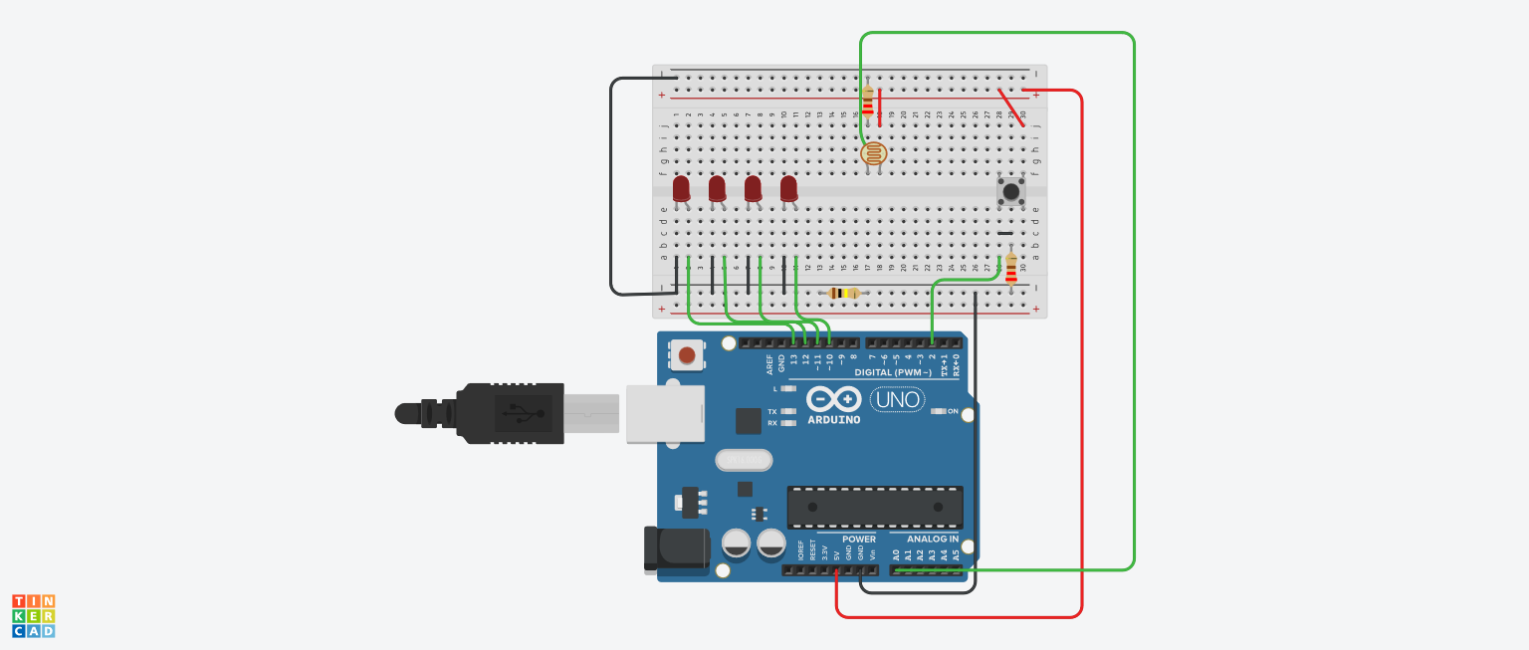

**THEORY**

**CONCEPT USED**

**Breadboard**

A breadboard is used to build and test circuits quickly before finalizing any circuit design. The breadboard has many holes into which circuit components like ICs and resistors can be inserted.

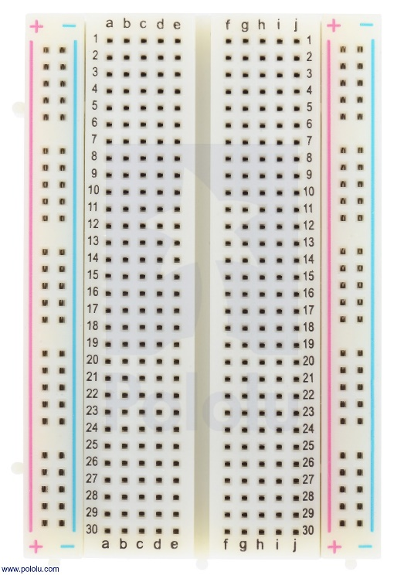

The bread board has strips of metal which run underneath the board and connect the holes on the top of the board. Note that the top and bottom rows of holes are connected horizontally while the remaining holes are connected vertically.

**LED**

A light-emitting diode (LED) is a semiconductor device that emits light when an electric current is passed through it. Light is produced when the particles that carry the current (known as electrons and holes) combine together within the semiconductor material.

**Characteristics Of LED:**

* **Polarity:** Polarity is an indication of symmetricity of an electronic component. A Light Emitting Diode, similar to a PN Junction Diode, is not symmetric i.e. it allows current to flow only in one direction.
* **More Current More Light:** The brightness of an LED depends on the amount of current drawn by the LED. Allowing current more than the rated current will actually burn the LED.
* **Low Energy Consumption:**  Most of the power delivered to an incandescent light goes to heating the electrons in the filament almost to the point that they emit visible light; it is the excess power beyond this point that provides illumination in the visible part of the electromagnetic spectrum. In LEDs the electrons require far less power to excite them enough to emit light.
* **Long Life:** No fragile parts, as conventional light bulb, to be broken. Light will decay lumen output, but rarely burn out or dead.

**LDR (Light Dependent Resistor)**

A Light Dependent Resistor (LDR) or a photo resistor is a device whose resistivity is a function of the incident electromagnetic radiation. Hence, they are light sensitive devices. They are also called as photo conductors, photo conductive cells or simply photocells.

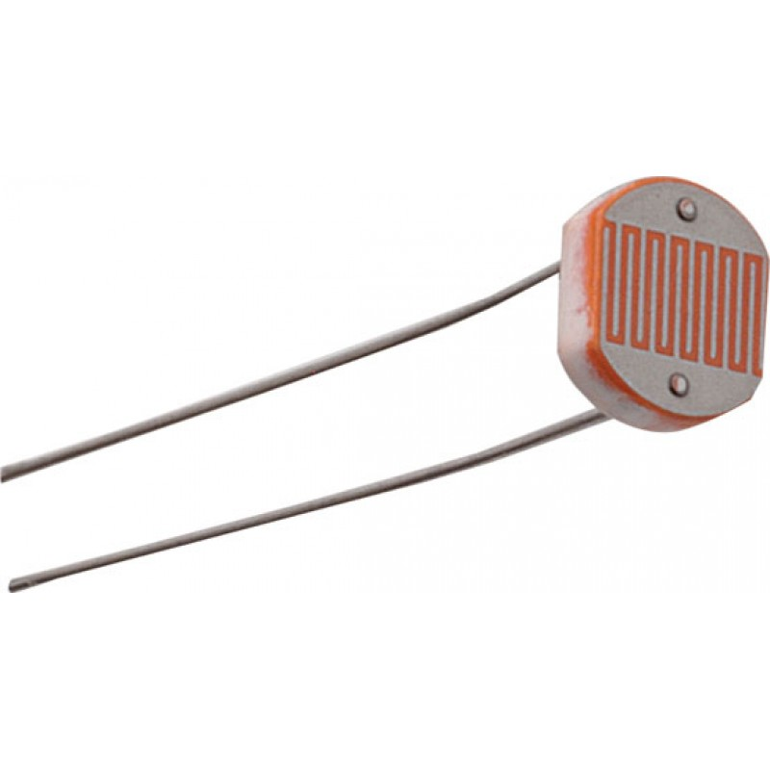

They are made up of semiconductor materials having high resistance. A light dependent resistor works on the principle of photo conductivity. Photo conductivity is an optical phenomenon in which the materials conductivity is increased when light is absorbed by the material.

**Characteristics of LDR:**

LDR’s are light dependent devices whose resistance is decreased when light falls on them and that is increased in the dark. When a light dependent resistor is kept in dark, its resistance is very high. This resistance is called as dark resistance. It can be as high as 1012 Ω and if the device is allowed to absorb light its resistance will be decreased drastically. If a constant voltage is applied to it and intensity of light is increased the current starts increasing.

**Push Button**

A Push Button switch is a type of switch which consists of a simple electric mechanism or air switch mechanism to turn something on or off. The button itself is usually constructed of a strong durable material such as metal or plastic. Push Button Switches come in a range of shapes and sizes.

**LEARNING & OBSERVATIONS**

1. LED consist of two legs: the longer leg is anode and the shorter is cathode. If the legs are equal by any chance, the smaller part is the anode and the larger part will be the cathode.
2. LEDs are directional, as light travels in one direction only.
3. Current flows from anode to cathode only.
4. Correct Board and USB port information should be selected before uploading the file.
5. How to use push button a switch in Arduino to take input signal.
6. How resistance decreases with increase in light lights and vice versa.

**PROBLEMS & TROUBLESHOOTING**

**Precautions**

1. The wiring/connections should be made proper.
2. Delay should be short to make a chaser.
3. Appropriate resistor should be used to minimize the flow of current so that it does not damage the LED.
4. One should be aware of the errors while running it to fix the problems.
5. Proper connection of LDR should be checked.

**Learning Outcomes**

1. Fluent in making Series and Parallel connection in a Breadboard.
2. Various methods to identify the anode and cathode of an LED.
3. Programming commands in Arduino IDE.
4. To use loops in Arduino.
5. Using SERIAL commands in Arduino to perform various tasks.
6. Using PUSH BUTTON to switch on and off leds.
7. To use LDR sensor to sense the intensity of light.